Predictive Dredging Models for the Upper Mississippi River and Illinois Waterway
Barrie Chileen Martinez
Department of Data Science, University of Wisconsin – La Crosse
DS 785: Capstone
Abstract
The Mississippi River and Illinois Waterways are high-traffic navigable channels that are used for commercial transportation. The U.S. Army Corps of Engineers (USACE) Rock Island District spends millions annually on dredging operations to maintain a 9-foot navigation channel. Currently, dredge coordinators rely on institutional knowledge and river forecasts to develop 10-14 day schedules, which is a reactive approach and vulnerable to personnel turnover and emergency groundings. This capstone developed machine learning models to extend forecasting windows and improve resource coordination. Using 25 years of river gage observations and shoaling rates derived from the Corps Shoaling Analysis Tool (CSAT), this study implemented ARIMA, PCA, xGBoost and LSTM approaches. The LSTM model achieved the strongest regression performance with RMSE values of 1.65 ft/yr (Illinois Waterway) and 2.69 ft/yr (Mississippi River) representing 18.9% and 28.9% improvement over the baseline ARIMA model. In classification tasks, xGBoost achieved 72.8% accuracy. Week of year and tributary gages were identified as strong predictors. These results provide a foundation for predictive modeling of dredging needs in inland waterways and can offer a framework for proactive, data-driven resource management in federal dredging operations.
Keywords: Sediment; Dredging; Shoaling; Timeseries; Forecasting
Problem Definition
Dredging is a critical mission assignment for the U.S. Army Corps of Engineers (USACE). The Rock Island District currently faces challenges in keeping pace with dredging needs and maintaining navigable channels on the Upper Mississippi River and Illinois Waterway. Current operations are reactive in nature; many groundings are addressed after surveys identify shoaling conditions and routing of dredging assets can take weeks depending on their current work schedule. This reactive approach results in inefficient resource allocation, with dredge units frequently rerouting to address emergency grounding situations that could have been prevented with improved forecasting.
Current operational challenges include:
- Limited forecasting windows of 10-14 days based on current river elevation forecasts
- Dependence on institutional knowledge is vulnerable to personnel changes and retirements
- Reactive scheduling which can be costly and reduces channel reliability
- Underuse of historic dredging and hydrosurvey data
By law, the USACE is required to maintain a 9-foot navigable channel on the Upper Mississippi River (UMR) and Illinois Waterway (IWW). Operations and maintenance of these channels can cost over $200 million annually, with emergency dredging contracts costing millions to mobilize. Inefficient operation of the channel results in commerce delays. Annually, the IWW provides about $3 billion of transportation cost savings and the upper Mississippi River system accounts for 25% of all waterborne commerce in the United States. The maintenance of this critical transportation corridor is paramount in ensuring the security of transported goods and the safety of those working and recreating on the rivers.
To ensure the effective maintenance and management of these key transportation systems, this study developed machine learning models to extend forecasting windows and improve overall routing of dredging assets. While machine learning applications have shown success in coastal districts with high-frequency survey locations, inland waterways are often overlooked in these applications. Studies in the Southwest Pass by Asborno et al. (2023, 2024) demonstrated that methods like xGBoost and LSTM were useful in shoaling prediction, however these approaches have not been adapted to the unique needs of inland waterways. This study addresses this gap by developing machine and deep learning models tailored to inland waterway conditions.
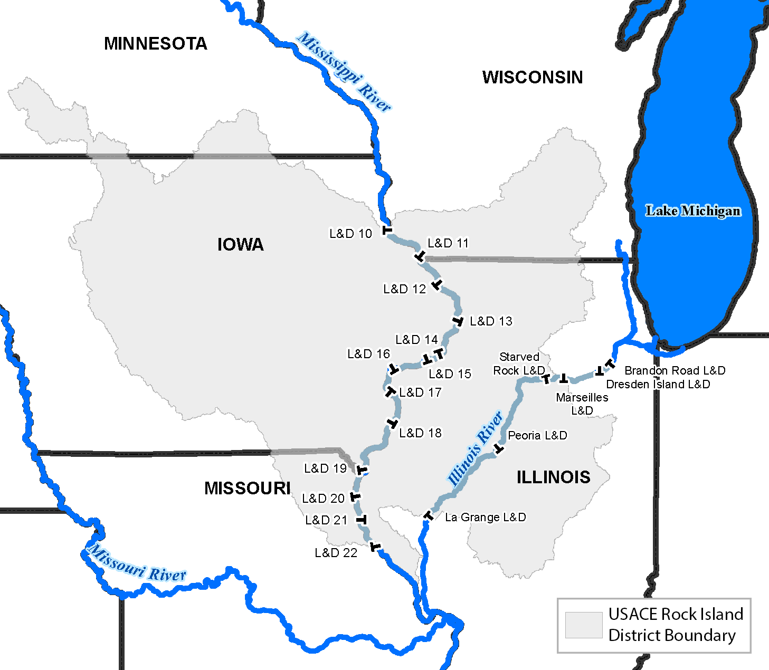
Study Area
Figure 1 Overview map of Rock Island District Area of Responsibility. The river gages used in this modeling effort are marked as points on the map
This study focuses on the two waterway systems maintained by the Rock Island District: the Upper Mississippi River and the Illinois Waterway.
Geographic Extent: The Mississippi River area of responsibility extends from river mile 300 to 610, encompassing pools 11 through 24. This 310-mile reach represents one-third of the upper navigation system which is managed by the St. Paul district to the north and the St. Louis district to the south. The Illinois Waterway spans river miles 79 to 290 which includes the Dresden, Marseilles, Starved Rock, Peoria, and LaGrange pools, for a total extent of 211 miles. (Fig 1). Both systems ultimately drain into the Gulf of Mexico through the Lower Mississippi River.
System Characteristics: While both contributing to the Lower Mississippi River, the Upper Mississippi River and Illinois Waterway each exhibit different physical characteristics. The substrate on the bottom of the Mississippi River can range from fine sand and silt to bedrock which can create complex sediment transport dynamics. The Mississippi River also has undergone significant fluvial geomorphological transformation through the implementation of the Lock and Dam system and the implementation of river training structures like wingdams. These water features influence both the velocity of flow and deposition of sediment within the channel.
The Illinois Waterway is urbanized and channelized system, especially within Chicago and its surrounding suburbs. The channel depth and flow are also managed by a series of locks and dams; a unique feature of the Illinois Waterway is that the Peoria and LaGrange locks are wicket dams. Unlike the Mississippi River, the Illinois Waterway does not have many river training structures. Surveying and dredging on the Illinois Waterway also persists longer than the Mississippi River due to its inability to ice over in the winter season, so it is possible to have year-round surveying and dredging on the Illinois Waterway.
Data Collection, Preparation and Cleaning
River Gage Data
The river gage data was acquired by pulling a bulk download from RiverGages.com and the tributary data was acquired using the USGS api. The period of record for the river gage forecast data is from January 1,1999 to December 31, 2024 which encompasses 25 years of river gage observations. There were 60 gages represented in the data with 35 gages associated with the Mississippi River and the remaining 25 associated with the Illinois Waterway. There were 9,497 rows of observations in the raw dataset. When operating, there are some instances where the gages malfunction or miss readings. To handle the gaps associated with these drops in data, river gage data was interpolated with a maximum gap of 4 days between interpolated records, which is appropriate for our river systems given how slow the levels change. After interpolating the data, missing values were reduced by 995 observations.
River gage observations represent daily average river elevation in feet. A metadata table accompanies this dataset to aid in mapping the gages to their respective river miles, pools, and rivers. The vertical datum for the Mississippi River is MSL 1912 and the vertical datum for the Illinois Waterway is NGVD 29. Over the period of record, the datums haven’t changed at these sites so conversion wasn’t needed. In addition to interpolating the empty rows, date variables were converted to date objects using the lubridate package and a categorical variable to represent season was created by assigning months 12, 1, and 2 as Winter, months 3,4,5 as spring, months 6,7,8 as summer and months 9,10,11 as fall. This variable was then factored for future analysis.
Hydrosurvey Data and Shoaling Rates
The Rock Island District maintains one of the oldest archives of hydrosurvey data within the USACE eHydro database for inland waterways. This historical dataset spans 25-years and contains over 10,300 hydrosurvey records which makes it a strong candidate for machine learning applications. These hydrosurvey records capture both pre and post dredge channel conditions as well as reconnaissance surveys over decades of hydrologic change. While coastal districts may have almost daily-resolution hydrosurvey records, Rock Island Districts historical dataset offers multiple channel scenarios that can serve as training data and capture the complexity in the relationship between channel flow and shoaling rates.
To transform the hydrosurvey surfaces into a useful predictor variable, this study implemented the Corps Shoaling Analysis Tool (CSAT). The eHydro data was pulled from the database in the form of .netCDF files. That data was then clipped to a derived channel boundary to better represent the navigable channel in place of the full bank-to-bank framework originally inherited by the tool. The clipping was done using a custom script in python. The .netCDF files were then run through the CSAT tool (Dunkin, Coe & Ratliff, 2018) which is a python library to create the shoaling rates used in this case study. The CSAT tool produced shoaling rates for survey date ranges within each reach of each pool in the Mississippi River and Illinois Waterway. The units for shoaling rate were feet per year which represents the rate of sediment change within a given reach. If shoaling rate is positive, shoaling increases and dredging is potentially needed to manage the condition of the channel. If the shoaling rate is negative, that indicates scour within the channel. The gage data was joined to the CSAT data by using the SurveyDateBefore variable and linking it to the date of the gage observation.
In order to contextualize the need for dredging, a shoaling rate threshold needed to be established for each river system. To do this, the shoaling rates from the CSAT tool were averaged across dates of dredging events recorded in Rock Island’s historic dredging database. Mean shoaling rates were calculated for the Mississippi River, the Illinois Waterway, and the rivers combined. If a forecasted shoaling rate matches or exceeds the shoaling rate threshold, the binary classifier for that point would indicate that Yes, dredging may be needed in the near future. The shoaling rate thresholds for the Mississippi River, Illinois Waterway and the rivers combined were 0.70 ft/yr, 0.48 ft/yr, and 0.63 ft/yr respectively. Pool level shoaling rate thresholds were also established to support pool-level analysis.
Exploratory Data Analysis and Feature Engineering
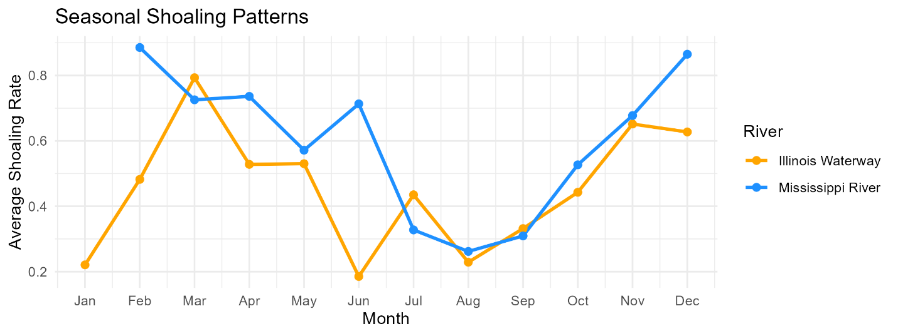
Once the CSAT data and gage data were collected, cleaned, and joined, the next steps were to assess the relationships between the predictor variables. With river gage data, it is expected that there is some level of collinearity due to river mechanics. Adjacent river gages are related to each other, so it is anticipated that there is a high level of collinearity between the gages in the system. To provide an overview of the collinearity of the dataset, all of the river gages and the week of year predictor were compiled into a correlation matrix. A correlogram was then used to visualize the relationships between predictors. Since we had 60 predictors, we reduced the final visualization to only contain the top 20 correlated predictors. To investigate the seasonality of shoaling, shoaling rates were averaged by month and plotted (Fig 2). As expected, shoaling rates are higher in the spring months for the Mississippi River and increase into the fall/winter months. This is most likely due to high flows in the spring which tend to decrease due to drought in the summer. Winter snow melt could also be driving the increased shoaling in winter/spring months. Based on these seasonal trends, a week-of-year and season attribute were created through feature engineering.
Figure 2 Seasonality of Shoaling Patterns in the Mississippi River and Illinois Waterway. Shoaling rates were averaged at a monthly scale.
A PCA plot was also created to provide another glimpse of the data (Fig 3) For the Illinois Waterway, PC1 captured 61% of the variance while PC2 captured 8.5% of the variance. For the Mississippi River, PC1 captured 74% and PC2 captured 8.05% of the variance. Key variables driving PC1 on the Mississippi River were the Muscatine River Gage and the Pool 16 Tail rivergage which are adjacent to each other. Another gage represented was the Burlington gage which is down river. On the Illinois Waterway, The LaSalle, Starved Rock Lock and Dam Tail, and the Copperas Creek River gage were strong contributors to PC1. The Illinois Waterway had a stronger pattern along PC1 compared to PC1 on the Mississippi River which indicates that there may be more complexities in the relationships between river gages within that system.

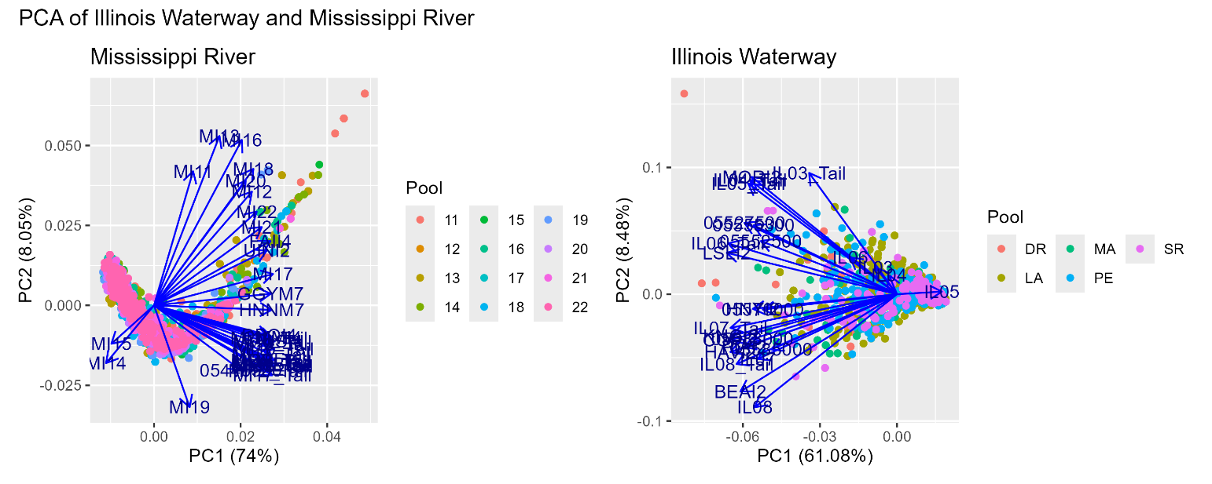
Model Development and Evaluation
Figure 3 PCA Plots of Mississippi River and Illinois Waterway river gage data. Points are colored by pool.
Levels of Analysis
For this analysis, there were two levels of splitting the data. xGBoost and LSTM models were run at the river level and at the pool level. These two resolutions offer insight to broad patterns at both the river scale and pool scale. The pool scale is most operationally useful as it enables dredge managers to assess dredging needs on a pool-by-pool basis. The river level analysis provided a proof-of-concept to indicate whether these types of modeling approaches can get reasonable results. Lessons learned on the river level analysis were then applied to the pool level analysis to speed up model development. Pool-level models selected gages within the pool as well as any gages upstream within 100-miles to capture system-wide impacts as the river flows through the channel.
Baseline Models
To assess the performance of xGBoost and LSTM, three baseline models were created. The persistence model approach predicts the same value as the most recent observation, representing the simplest forecast. The median model approach applies the median from the training set to all predicted shoaling rates. The ARIMA model approach uses autoregression and moving averages to capture temporal patterns in the data. ARIMA models have proven effective in hydrologic and environmental forecasting applications, making it the primary baseline for comparison. The results of the baseline models are included in the table below at both the river level and pool level (Table 2). The ARIMA model achieved an RMSE of 3.64 ft/yr for the Mississippi River and an RMSE of 2.03 ft/yr for the Illinois waterway, establishing the benchmark point of comparison for the machine learning approaches.

Table 2. ARIMA Baseline Model Results
River | Test RMSE (ft/yr) | Test MAE (ft/yr)
Mississippi River | 3.64 | 1.86
Illinois Waterway | 2.03 | 1.16
Rivers Combined | 3.53 | 1.84

The data was split temporarily using 70% for training, 15% for validation, and 15% for testing to prevent temporal data leakage and to ensure that the models were evaluated on temporal sequences in the future. The same training, validation, and test split were used for all models in this study.
xGBoost
Extreme Gradient Boosting (xGBoost) is a machine learning approach that is especially flexible in working with datasets that have high levels of collinearity and can be applied to temporal forecasting scenarios. xGBoost also creates easily interpretable feature importance rankings that can aid in interpreting model output and predictors of interest in developing predictive dredging models. Model training was conducted using the TrainControl function in R from the Caret package. 5-fold temporal cross validation was used for model training and the temporal-sequencing of the data was maintained through the train/control splits established during the baseline ARIMA model development.
For the river level model, a tuning grid was created for hyperparameter optimization and tested the following parameter configurations: number of rounds (100,200), maximum tree depth (4,5), learning rate (0.05,0.1), gamma regularization (0,0.1), column subsampling ratio (0.6,0.8), minimum child weights (1,3) and the row subsampling ratio (0.8,1.0). The best-tuning configuration was selected using RMSE. For the pool-level model the hyperparameter tuning grid was: number of rounds (50,100,150), maximum tree depth (3,4,5,6), learning rate (0.05,0.1,0.2), gamma regularization (0,0.1), column subsampling ratio (0.7,0.9), minimum child weights (1,3) and the row subsampling ratio (0.8). The pool-level xGBoost models tested a larger range of tuning parameters since the pool-level datasets were smaller and faster to train than the river-level datasets. The best parameter configuration was also selected using RMSE.
Once the xGBoost models were run, the predicted shoaling rate output was converted into a binary classifier to indicate dredging need based on the established thresholds (0.70 ft/yr Mississippi River, 0.48 ft/yr for the Illinois Waterway, and 0.63 ft/yr for the rivers combined). Classification performance metrics including accuracy, precision, recall, and F1 score were calculated to assess overall model performance. Variable importance analysis indicated that Week Of the Year is an important predictor as it showed up in the top ten across all three frame of river analysis. On the Illinois Waterway. The gage at Brandon Road Lock and Dam and the gage at the tail of Marseilles are strong indicators while for the Mississippi River, Lock and Dam 14 and the Fairport River gage had the higher ranks of importance.
Long Short-Term Memory (LSTM)
Long Short-Term Memory models were implemented to capture the complex temporal patterns in the shoaling data. In river systems, activity upstream has effects downstream the channel. In order to capture this relationship, LSTM models are able to maintain context and memory in forecasting applications. If a gage isn’t contributing in a substantial way, as measured by reducing the RMSE or MAE, the LSTM is able to forget that context over long sequences. This is especially well-suited for applications relating to hydrologic time series where events, like sustained flooding from weeks prior to a given forecast, can substantially influence the rate of shoaling and sediment drop-out within a channel.
Model Architecture and Sequence Development
The input river gage time series data was transformed into input sequences with a lookback window of 30 days. Each prediction within the sequence is able to integrate the past 30 observations of gage readings in its forecasting activity. The model was then configured to create 45-day forecasts, with intermediate steps, in order to extend beyond the current 10-14 day operational forecasting window. Features were scaled and centered using z-score normalization from the training data. The final architecture of the LSTM model consisted of three laysers with 128, 64, and 32 units. A dropout rate of 0.2 was applied to prevent overfitting and each layer was batch normalized between layers
Results, Insights and Recommendations
Conclusion
References
Asborno, Magdalena, Jacob Broders, Kenneth N. Mitchell, Michael A. Hartman, and Lauren D. Dunkin. "Forecasting Sediment Accumulation in the Southwest Pass with Machine-Learning Models." Journal of Waterway, Port, Coastal, and Ocean Engineering 150, no. 2 (2024): 04023022.
Asborno, Magdalena and Broders, Jacob and Mitchell, Kenneth Ned and Hartman, Michael A. and Dunkin, Lauren M., Selection of Hydrological Variables to Forecast Shoaling with Xgb. Available at SSRN: https://ssrn.com/abstract=4641922 or http://dx.doi.org/10.2139/ssrn.4641922
Dunkin, Lauren M., Lauren A. Coe, and Jay J. Ratcliff. "Corps shoaling analysis tool: Predicting channel shoaling." (2018).
Yeates, E. M., Tavakoly, A. A., Mitchell, K. N., Dreaper, G. W., & Afshari, S. (2020). Utilizing stream flows to forecast dredging requirements (No. ERDCCHLTR2017).

